Data Science with R Programming

1.Stastics

2.Regression

3.Visulaization

4.Machine Learning

5.Deep learning

Getting user from user

Vector

Matrix transverse

Slicing

Dataframes

Filling Nan

Splicing

Factors

String as factors

Factors are the data objects which are used to categorize the data and store it as levels

Random function

Sample

Runif

Decision statements

TRUE

FALSE

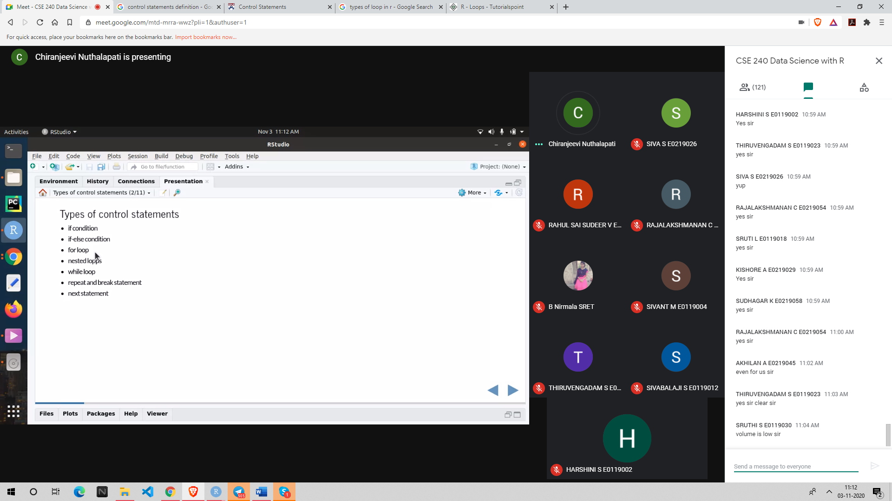

if

If else

For

Nested loops

Repeat loop

Break statement

Functions

Variables globally assigned

Data visualiztaion:

Charts,grap,map

Graphical represnetion of information and data

Understanding large amount of data

Ggplot has 6 layers ggplot – (grammar of graphics)

Data

Aestatics

Geometry

Facets

Statistics

Coordinates

Themes

Plots except ggplot in r

